Match the following Political Cartoon with the best descriptor:

_____Declared the United States to be the “policemen” of the Western Hemisphere
_____The United States should not join the League of Nations because it might be pulled into
other nations’ disputes.
_____ This cartoon from 1916 represents the decreasing neutrality of the U.S. in WWI
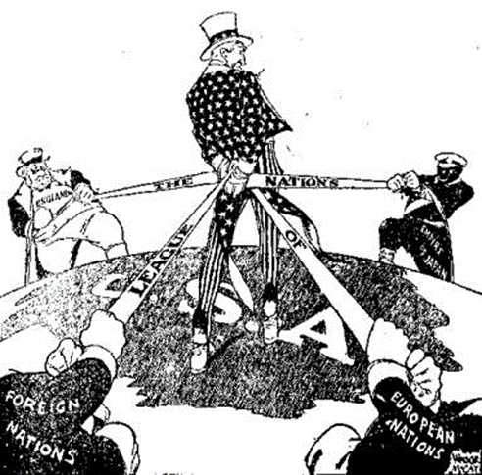
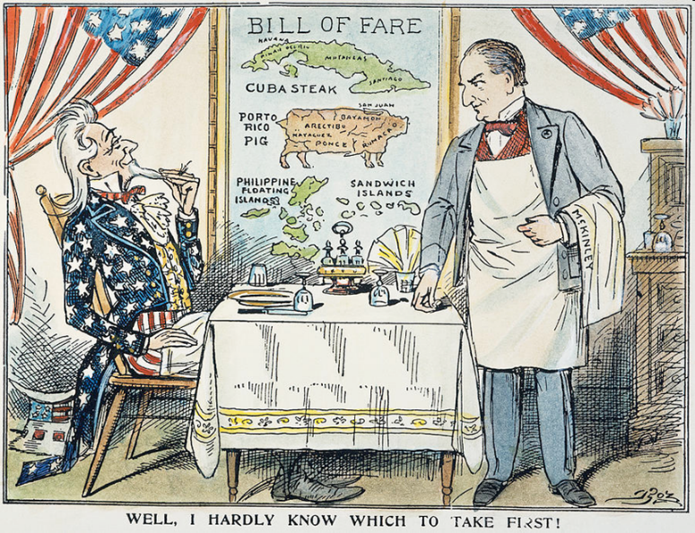
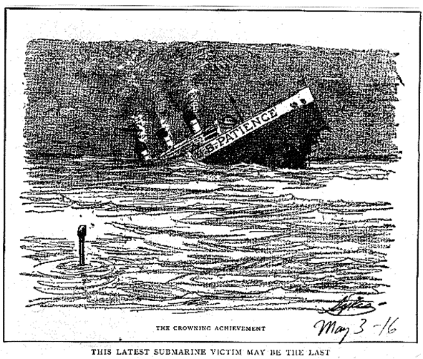
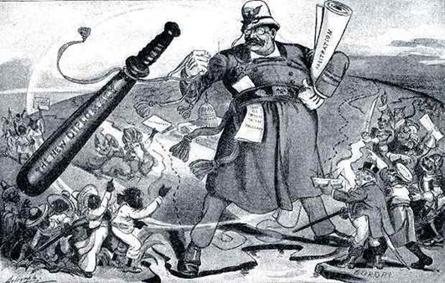
_____ This cartoon represents the controversy over American Expansionism.
4.
3
2.
1.

- True or False - The threat of using military force in foreign policy best describes big stick diplomacy and represents one of President Theodore Roosevelt's favorite phrases which was “Speak softly, and carry a big stick, you will go far."
- True or False - In 1895, Secretary of State Richard Olney sent a letter to Great Britain asking them to use arbitration to settle the boundary dispute between Venezuela and British Guiana was an action that was an example of a U.S. intervention in foreign affairs that the U.S. claimed was justified by the principles set forth in the Monroe Doctrine.
- In 1895, Secretary of State Richard Olney sent a letter to Great Britain asking them to use arbitration to settle the boundary dispute between Venezuela and British Guiana. The justification for this was set forth by which foreign policy doctrine of the early 19th century?
- True or False - The Monroe Doctrine extended to financial matters as well as shown by President Theodore Roosevelt’s address to Congress in 1904 when he stated that the United States would intervene in the finances of countries in the Western Hemisphere who were unable to pay their debts to foreign creditors.
- The United States assisted in a Panamanian revolt against which country, after the country refused to recognize a treaty with the U.S., in order for Panama to gain its independence and thus facilitate the building of the Panama Canal?
- What was the first territory that the United States acquired in the Pacific Ocean?
- The Treaty of Paris of 1898 ended which war?
- What were the two ships sunk by German U-boats, that subsequently killed and/or injured American passengers, prior to the US entering WWI that we discussed in class?
- The Zimmerman Letter convinced many Americans that the U.S. should do what?
- Southern Blacks were the primary group of what early 20th Century nomadic phenomenon?
- The Philippines, Guam, and Puerto Rico were acquisitions of the U.S. as a result of what?
- As a result of Congress’ concerns that involvement would override American interests for European ones, Congress said NO to U.S. participation in what endeavor that was established by the Treaty of Versailles at the end of World War I?
- In order to maintain world peace, President Woodrow Wilson wanted the United States to participate in what, following the Treaty of Versailles?
- What was the name of journalistic activity in newspapers that often exaggerated the severity of the situation that existed in Cuba, prompting pro war sentiments against Spain, used by William Randolph Hearst and Joseph Pulitzer in order to increase the circulation of their newspapers?
- True or False - The Northeast US, Midwestern US, and Southern California were destinations for the Great Migration of the early 20th century.
- What color were the majority of men drafted into the Armed Forces during WWI?
- This was a volunteer cavalry unit in the Spanish-American War.
- True or False - A condition imposed on Germany as a result of the Treaty of Versailles was that the German blockade of France had to be removed.
- The interception of this was an immediate cause of the U.S. entry into World War I.
- True or False - The Chinese Exclusion Act, passed by the U.S. Congress in 1882 as a result of American nativism, prohibited any further Chinese immigration for 10 years?
- Cuba gained its independence from Spain as a result of what war?
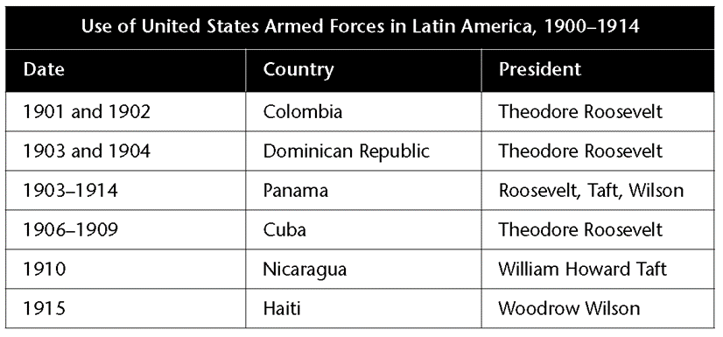
- According to this chart below, which TWO presidents resorted most frequently to the use of U.S. Troops in Latin America?

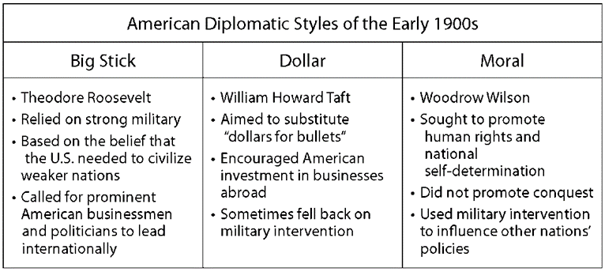
- According to the chart below, which was LEAST likely to use military action.

- He was the leader of the American Railway Union, a Socialist, and ran for president in 1912.
- This Constitutional Amendment made the manufacturing, sale, and transportation of alcohol illegal in the U.S.
- This Constitutional Amendment granted women the right to vote.
- This Congressional action, passed in 1917, established penalties and prison time for aiding the enemy as well as penalized disloyalty and/or interference with the war effort and/or military recruitment.
- This congressional act gave the US the right to intervene in Cuba’s internal affairs and secured land in Cuba for America to build military bases.
- This treaty established the Panama Canal Zone and the subsequent construction of the Panama Canal.
- True / False – All of the following were part of Wilson’s 14 Points: Free trade and open seas, No secret alliances, Self-Determination in Europe, and U.S. colonization of Latin American.
- President Taft’s foreign policy encouraged American investment in foreign countries. What was the name given to Taft’s foreign policy?
- Why was the Selective Service passed by Congress in May 1917? Why was it needed?
- Who started the War Industries Board (WIB) and what was its purpose?
- What was the purpose of the Teller Amendment?

